Brought to you by
The Texas A&M University System Benefits Administration
Mar 2019
Issue 66

Benefit Briefs

Retirement Vendor Webinar
Money at Work 1: Foundations of Investing
Discover how you can manage risk versus reward, as well as understand the role of investing and managing risks, ways to help accelerate savings and tools that can help sustain a portfolio.
March 13 at 2 p.m. (CT)

*

*MDLive is available to covered employees, dependents, and retirees for a $20 copay; Mdlive.com/tamus

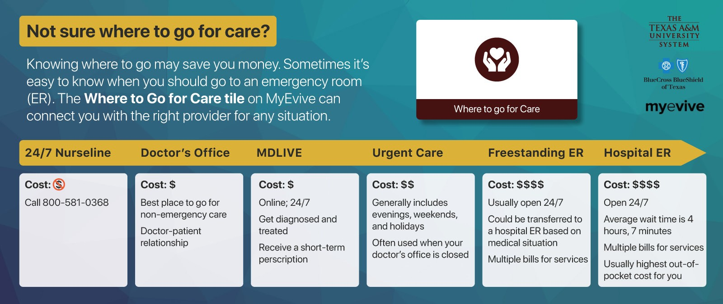TIAA.org/webinars

Medicare Part D Reminder
If you are enrolled in the Medicare Part D Prescription drug plan and are having prescriptions filled, you must use your new Medicare Part D plan card. You and any covered dependents will have different identification numbers. The group number, TAMUS65PLUSSTD (TAMUSDRX), for the
Medicare Part D plan is also different than the A&M Care Prescription Drug plan.

MyEvive and the Health
Assessment
The A&M System, along with Blue Cross and Blue Shield (BCBSTX), has partnered with Evive since mid-2015, as a way for members to access health and other insurance information more easily. We began with wellness incentive information, progressed to leveraging Evive to help us communicate health information and eventually partnered with them to provide our jointly created Health Assessment (HA).
While the HA does ask some health-related questions, its main purpose is to survey interest in lifestyle improvements such as sleep, stress, exercise and nutrition. This allows Evive to provide the member with information about programs tailored to his/her needs and wants. These programs are available at no cost, through Evive, BCBSTX, or through the A&M System. We believe this is a great way to communicate lesser-known programs to employees.
For example, if you complete your HA and indicate a medium to high level of stress, you can receive information about programs geared toward stress management, whereas if another person indicates that she/he is financially stressed, that person will receive information about financial webinars, etc.
In addition to sharing our offerings with the right population, Evive also assists in adherence to preventive tests and chronic medications.
In hopes of better managing plan costs, we
are taking every opportunity to communicate and encourage preventive practices. Evive’s suggestions are based on the nationally- recommended United States Preventive Services Task Force guidelines, which are targeted at developing an overall healthier population. Due to this partnership, the A&M System has been able to reduce risk by engaging at-risk members with disease management and prevention programs and improving adherence rates for nationally-recommended guidelines. By engaging more members in care, the cost for many conditions is below the BCBSTX benchmark because those conditions can be identified and treated earlier. These strategies have helped make the A&M System’s wellness program a recognized industry leader within higher education in Texas.
Evive has taken the appropriate security measures to ensure that information being shared with them remains confidential.
They are very aware of the sensitivity of personal information and are held to the same standards as all of
our insurance vendors with respect to data privacy.

None of the HA information is sent to the A&M System except as aggregate, de-identified information in the form of percentages (ex: 50% of those who answered indicated that they drink more than 8 oz. of water a day).
With regard to privacy agreements, BCBSTX is not only a Business Associate of ours, with whom we have a Business Associate Agreement, a particular agreement under HIPAA laws that covers all matter of HIPAA situations, but BCBSTX itself is a HIPAA entity, meaning that it is required by law to uphold HIPAA rules and regulations by virtue of the business it conducts. Evive, as a partner of BCBSTX, has a HIPAA agreement with BCBSTX that covers A&M System employees and their information.
The Wellness Incentive is an opt-in program. Employees and their enrolled spouses can complete the two steps – take an annual health exam and take the Health Assessment - to receive a reduction in their health premiums.
A&M System benefit programs are continuously being reviewed for improvement. Participation in the wellness incentive program is one way that we can assess both the general health and well-being of our enrolled population and their interests in our value-added programs. This allows us to make more educated decisions about the needs of A&M System employees.

SEBAC Highlights
The System Employee Benefits Advisory Committee met for the second time during FY19 on February 26, 2019. The current state of the benefit plans was discussed. Below are some highlights from the meeting:
- Health plan enrollment increased slightly. There are currently 29,391 covered employees and retirees, and 25,559 covered dependents. Total paid claims for the health plan are slightly higher than at the same time during FY18
and total $23.5M as of the end of December.
- A total of 7,181 retirees are now enrolled in the 65 Plus plan with Medicare Part D.
- Dental PPO plan participation remains high with 23,220 covered employees and retirees, and 21,116 covered dependents.
- A subcommittee was established to review retiree communication strategies.
- Around 5,500 people have taken the Health Assessment through MyEvive to date.
- The number of Catapult on-site exams has doubled from last year at this time.
- MDLive, the new virtual visit service that allows covered plan participants to talk to a doctor via video and phone, has been active for 4 months. We are on track for utilization comparable to other higher education entities.
- Blue Cross and Blue Shield of Texas reported that cancer continues to be the System’s highest diagnostic category followed by musculoskeletal and circulatory conditions.
- The A&M System student and grad student plan is a good value both benefit-wise and cost-wise compared to gold and platinum plans on the market place and other plans at schools in Texas.
- The trend in the student and grad student plan appears to be putting us at the low end of potential increases for FY2020 of between 6.5% and 12.5%.
- The biggest cost driver in student plans for last year across the country, as well as in our plan, was prescription drugs.

Express Scripts Program Updates

The Smart90 Retail Network for Medicare Part D
The Smart90 Network is part of the new Express Scripts Medicare Part D prescription plan, managed by Express Scripts. You do not have to get a 90-day supply of your maintenance medications. But to get a 90-day supply, you must either:
- fill those prescriptions through Walgreens,
- use home delivery from the Express Scripts Pharmacy
.
SM
- use an independent retail pharmacy in the Smart90 network.
If you were participating in the Diabetes Care Value Program, you can continue to receive your 90-day supply from the same location.
To find out more information or to locate a pharmacy in the Smart90 network, contact Express Scripts Medicare customer service at 1-855-895-4647.

Migraine Care Value Program
The Migraine Care Value Program is a new program developed by Express Scripts to assist acute migraine sufferers. Specialist pharmacists in the Neuroscience Therapeutic Resource Center will identify patients who use high amounts of acute migraine treatments, and work with them and their physician to move them to an appropriate preventive treatment.
Once on the preventive therapy program, the specialist pharmacists will offer coaching to make sure you stay on the medicine and avoid migraine triggers.
You are considered to be experiencing acute migraines if you suffer from 4 or more a month. The program begins April 1. Contact Express Scripts for more detail at 1-866-544-6970.

BCBS Fitness Program: No Enrollment in March
The Blue Cross and Blue Shield Fitness Program enrollment fee of $25 will be waived for eligible new members who sign up between March 1 and March 31. You will be asked to enter a coupon code, SPRINGSAVE25, at checkout to qualify for the waived fee. You will have access to a nationwide network of more than 10,000 participating facilities so you can work out whether traveling, at home or at work. Please note that you must be
a member of a participating location to join the fitness
program.
To enroll or search for participating locations, log

Musculoskeletal conditions are experiencing the fastest
in to Blue Access for Members
and click

growth from the prior year.
“Fitness Program” in the
SM
Quick Links

- Health plans are evolving towards a well-being .
management structure, which involves increasing targeted
communications to raise awareness and boost utilization of existing programs.
section. You can also enroll by calling 888-762-2583, Monday through
Friday, between 7 am and 7 pm CT.

