Onsite Wellness Exams
Location Detail

Main Campus – Memorial Student Center (MSC)
Corner of Joe Routt Bl. and Houston St.
Room # 1400

Wednesday, March 4, 2015
Note your appointment time here:
Building
Map:

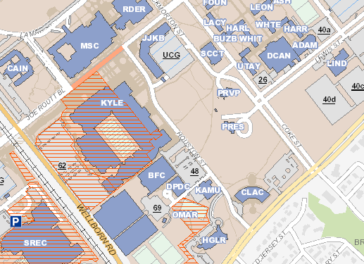
Parking
Directions:

From University and Texas Avenue, go South on Texas Ave. Turn right onto Houston St. The Memorial Student Center (MSC) is the building straight in front of you when it ends at Joe Routt.

Bus Route:

Any route to the MSC.

Parking:

There is visitor parking available in the University Campus Garage (UCG). The Texas A&M University Health Fair will also be going on at this time so it may be crowded in the garage for the event.

