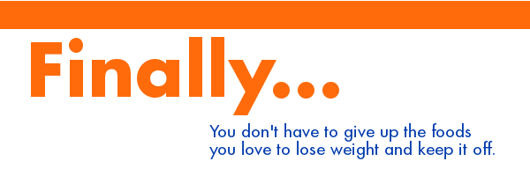
The Texas A&M University System is offering you, an opportunity to lose weight
with a program called Naturally Slim® – at no cost to you!

Naturally Slim is a 10-week online program that helps you lose weight
plus improve your overall health – all while eating the foods you love!
With Naturally Slim, you will learn that you don’t have to starve yourself or
count calories to lose weight and keep it off forever.

How does the Naturally Slim program work?
Naturally Slim is a mindful-eating program that helps you change how you eat
instead of what you eat. It is not a diet.
And, as you lose weight, you also improve your health by improving
the risk factors that can lead to serious, chronic diseases like diabetes,
heart disease, cancer and more.

Why not give it a try? You can still eat the foods you love and this could
be the solution that you’ve been looking for. Thousands of people have used
the Naturally Slim program to successfully lose weight.
The average weight loss in just ten weeks is 10.1 pounds.
In fact, 15% of participants lose more than 20 pounds in that time.

How do I apply?
The program begins on July 13th
but participation is limited so you must complete the online application at
www.naturallyslim.com/TAMUS
by June 26th.
Please note: By submitting the online application,
you are committing to participate in the program, if accepted.

Frequently Asked Questions:

How will participants be selected?
Program professionals select participants based on pre-determined criteria including participation in our health plan and presence of certain health risk factors as well as a willingness to meet all program completion requirements as outlined below. You will be notified of your application status via e-mail by July 2nd.

What are the program completion requirements?
In order to successfully complete the program, you must:
- Submit the online application and sign all appropriate releases
by their associated deadlines.
- Complete at least 8 of the 10 online video courses for Naturally Slim Foundations, within their set weekly time frames. It will be your responsibility to ensure your participation is accurately recorded each week.
- Complete a survey at the end of the program.
- If you complete at least 5 weeks of the program you will receive a Naturally Slim water bottle.
- If you complete all 10 online class sessions, you will automatically be entered into a random drawing for a chance to win a FitBit® Flex activity wristband.
- As part of this system-wide pilot and in an effort to make you aware of your own health, there will be a place to record biometric data (height, weight, waist circumference, triglycerides, total cholesterol, HDL, LDL, fasting glucose, blood pressure) on your application as well as after you have completed the Foundations program.

What is the cost for the program?
There is no cost to you for the Naturally Slim program. Your participation will help the Texas A&M University System achieve our goal of becoming a more health-conscious organization.

A Note About Confidentiality…
The information that you provide to Naturally Slim will be considered confidential and will be available only to you and the program professionals. The Texas A&M University System will receive participation reports for administration of payroll and billing processes. Otherwise, the information you provide to Naturally Slim is confidential and available only to you and Naturally Slim and its affiliates involved in conducting or evaluating the program. Naturally Slim cannot sell or otherwise divulge any participant information to any unauthorized party.

Fitbit is a registered trademark and service mark of Fitbit, Inc.

